
East West University
Lab Report
Semester: Summer-2025
Course Title: Electronic Circuits Course Code: CSE251
Section: 04

Expt No: 07
Expt Name: Biasing of a Common-Source Voltage Amplifier
Group No: 06
Group Members:
Student Name | Student Id
Md. Hasib Ali | 2023-3-60-186
Arijit Kumar Anoy | 2023-3-60-055
Md. Shakib Al Hasan | 2024-1-60-200
Fahim Shahriar | 2023-2-60-094
Morshedul Islam | 2023-2-60-125

Submitted by-
Name: Md. Shakib Al Hasan
Id: 2024-1-60-200

Submitted to-
Dr. Sarwar Jahan
Associate Professor
Department of Computer Science & Engineering
East West University

Date of Performance: August 18, 2025
Date of Submission: August 25, 2025
Title: Biasing of a Common-Source Voltage Amplifier

Objectives
The objective is to identify an appropriate DC operating point for a NMOS transistor.

Theory (Summary)
This experiment explains the operation of a common-source amplifier using an NMOS transistor. It details the biasing process, which involves fixing the gate voltage with a voltage divider and using a source resistor ($R_{S}$) to stabilize the bias current. The source resistor provides negative feedback, helping to maintain consistent performance despite temperature variations and transistor characteristics. The text also discusses selecting resistors to ensure the drain voltage ($V_{DS}$) is about half of ($V_{DD}$), allowing for a large and symmetrical output swing. Additionally, it highlights the importance of transconductance (gm), which measures the rate of change of the output current concerning the input voltage ($V_{GS}$). Equations are provided to calculate the drain current ($i_{D}$) and transconductance ($g_{m}$).

Equipment and Component
1. Digital trainer board
2. DC power supply
3. Digital multimeter
4. DC Voltmeter
5. CD4007C IC (1 pc)
6. Resistor (1ΚΩ 1 pc)
7. Breadboard
8. Connecting wires

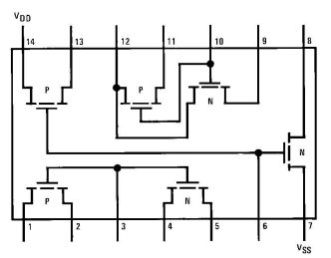
Circuit Diagram

Figure-1: Pin diagram of CD4007C IC.
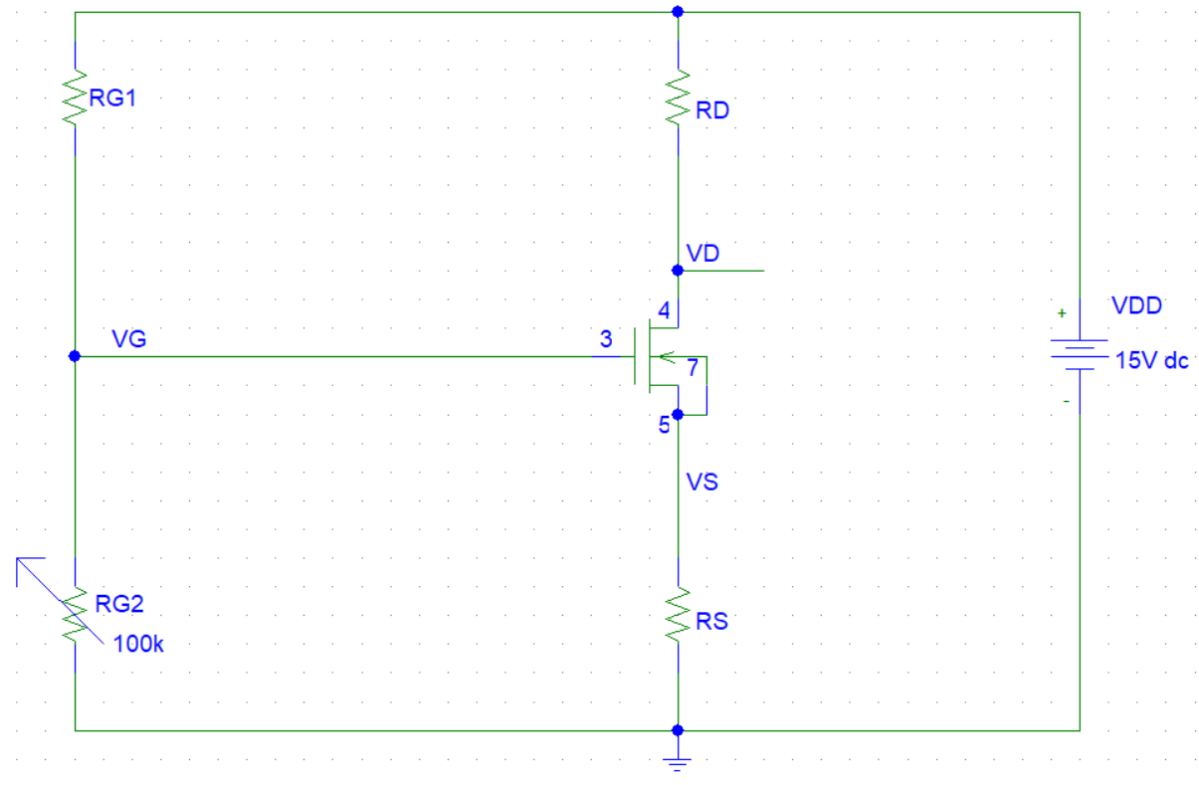

Figure-2
Pre-Lab
Here,
Bias Current, $I_{D}=0.6mA$
Source Voltage, $V_{S}=4V$
$V_{t}=1.2V$
$K_{n}^{́}\left(\frac{W}{L}\right)=0.7mA/V^{2}$

$V_{D}$ is middle of $V_{s}$ and $V_{DD}$
⸫ $V_{D}=\frac{V_{S}+V_{DD}}{2}=\frac{4+15}{2}=9.5V$
⸫ $R_{D}=\frac{V_{DD}-V_{D}}{I_{D}}=\frac{15-9.5}{0.6}=9.167KΩ$
⸫ $R_{S}=\frac{V_{S}}{I_{D}}=\frac{4}{0.6}=6.667KΩ$

We know,
$$I_{D}=\frac{1}{2} K_{n}^{́}\left(\frac{W}{L}\right){\left(V_{GS}-V_{t}\right)}^{2}$$
⸫ $V_{GS}=\sqrt{\frac{2×I_{D}}{K_{n}^{́}\left(\frac{W}{L}\right)}}+V_{t}=\sqrt{\frac{2×0.6}{0.7}}+1.2=2.51V$
⸫ $V_{G}=V_{GS}+V_{S}=2.51+4=6.51V$

Using VDR,
$$V_{G}=\frac{R_{G_{2}}}{{R_{G_{1}}+R}_{G_{2}}}×V_{DD}$$
⸫ $R_{G_{1}}=\left(\frac{V_{DD}}{V_{G}}-1\right)R_{G_{2}}=\left(\frac{15}{6.51}-1\right)100=130.4kΩ$

Total input resistance, $R_{G}=R_{G_{1}}∥R_{G_{2}}$
⸫ $R_{G}=\frac{R_{G_{1}}×R_{G_{2}}}{R_{G_{1}}+R_{G_{2}}}=\frac{130.4×100}{130.4+100}=56.6KΩ$
$$I_{G}=\frac{V_{DD}}{{R_{G_{1}}+R}_{G_{2}}}=\frac{15}{130.4+100}=0.0651mA$$
⸫ $I_{total}=I_{D}+I_{G}=0.6+0.0651=0.6651mA$

Total DC power dissipation,
$P_{DC}=V_{DD}×I_{total}=15×0.6651=99765mW$
Experimental Datasheet
Sample No. | $R_{G_{1}}$ KΩ | $$R_{D}$$  KΩ | $$R_{S}$$  KΩ | $$R_{G_{2}}$$  KΩ | $V_{D}$(V) | $V_{S}$(V) | $V_{G}$(V) | $V_{DS}$(V) | $$I_{D}$$  mA
1 | 97 | 8.621 | 6.165 | 70.145 | 4.82 | 3.5 | 5.127 | 1.32 | 0.5677
2 |  |  |  | 80.55 | 5.059 | 3.736 | 4.875 | 1.322 | 0.606
3 |  |  |  | 90.002 | 5.1 | 3.78 | 4.82 | 1.32 | 0.613

For sample 1,
$$I_{D}=\frac{V_{S}}{R_{S}}=\frac{3.5}{6.165}=0.5667mA$$

For sample 2,
$$I_{D}=\frac{V_{S}}{R_{S}}=\frac{4.875}{6.165}=0.606mA$$

For sample 3,
$$I_{D}=\frac{V_{S}}{R_{S}}=\frac{4.82}{6.165}=0.613mA$$

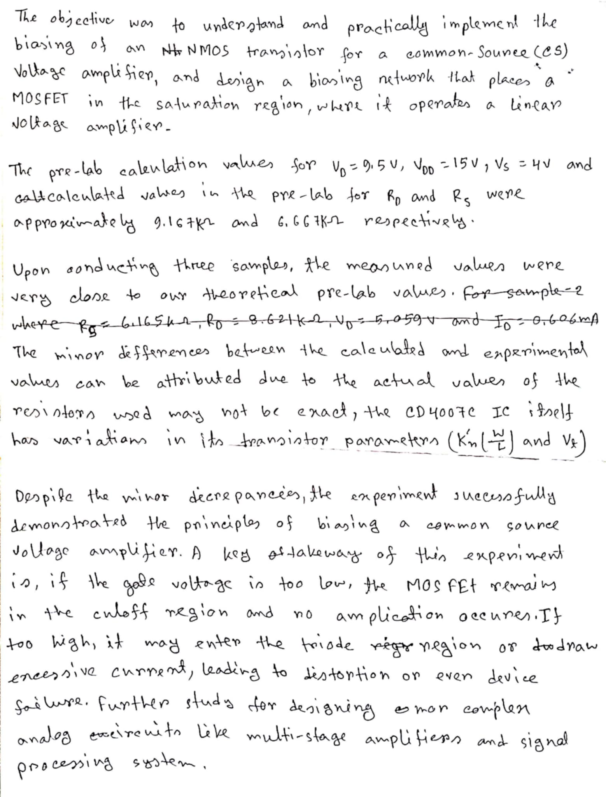
Discussion

